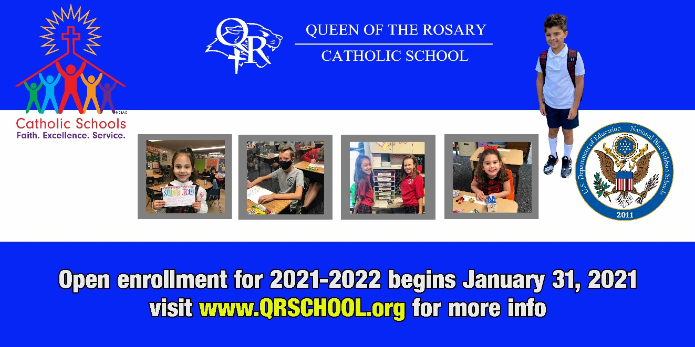

Queen of the Rosary School provides faith-based academics and enriching experiences for those seeking quality Catholic education. The most important mission of parish schools, besides teaching who Jesus is, is to transform the lives of children so they can one day lead change in the world. Our faculty and staff support each child during their years with us, and our students learn they are a part of something greater than themselves. When Queen of the Rosary students go on to high school, they succeed academically; they are viewed as compassionate, academically strong, and faith-filled leaders.

We invite you to get to know Queen of the Rosary School on a more personal level. Please join us on January 31, 2020 for our Virtual Open House to learn more about our school, programs, and dynamic community so you can determine if Queen of the Rosary School is a great fit for your child/ren and family.

Virtual Open House and Registration: https://qrschool.org/cms/One.aspx?portalId=240938&pageId=44335735

Once you register for the Virtual Open House, you will be sent an email containing a link to the tour, photos and videos. Additionally, information on registration for the 2021-2022 school year will be provided.
In-Person Tour
An in-person tour of our school may be scheduled from Sunday, January 31 through Friday, February 5. Due to current restrictions, tours are scheduled to take place when students are not in the building and will follow appropriate social distancing. Masks are required.

Please contact the school office (847-437-3322) or email (kmcginn@qrcougars.org ) to request an in-person tour..

